Test Case: tc002_SPX_Dev5_Crear_Requisicion_Spot_Con_FAD_Tipo_Cobro_CC
Step 1 - Enter username and password and click to button Enter : Credentials Entered
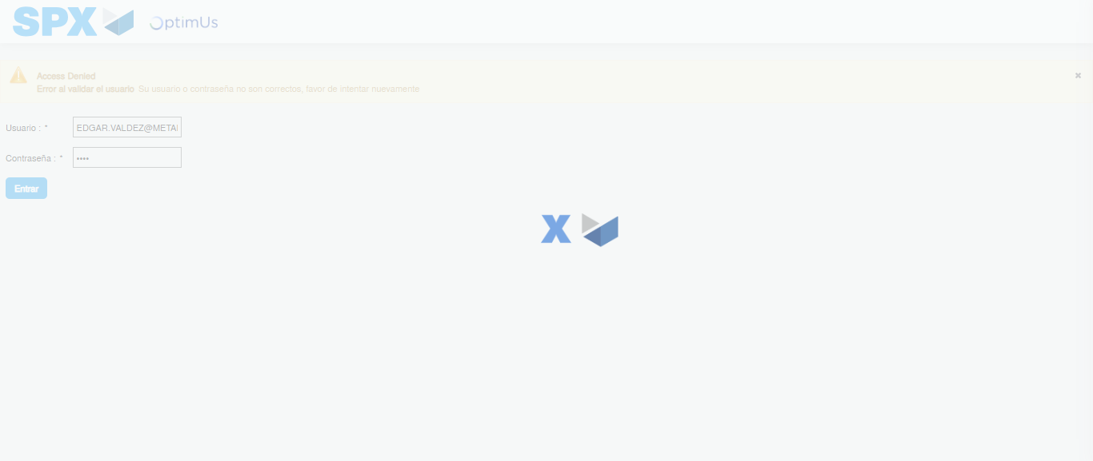Image file-name: QC_Testing-tc002_SPX_Dev5_Crear_Requisicion_Spot_Con_FAD_Tipo_Cobro_CC-1781656123262

Step 2 - Select to UEN and Access to Spot Buy Requisitions : UEN Correctly selected and Correct access
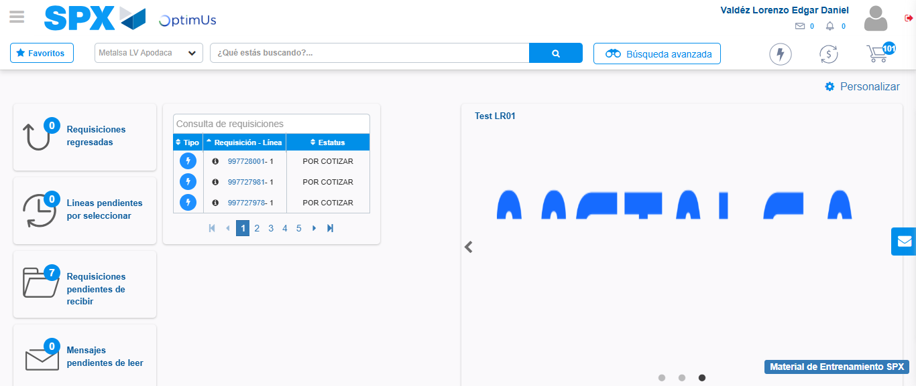Image file-name: QC_Testing-tc002_SPX_Dev5_Crear_Requisicion_Spot_Con_FAD_Tipo_Cobro_CC-1781656149370

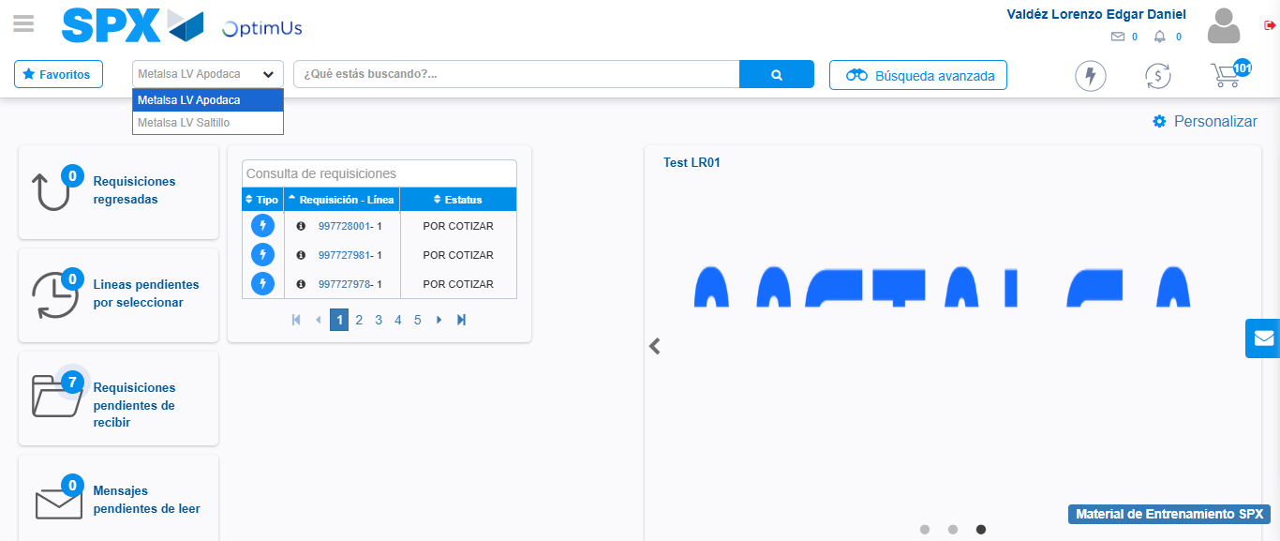Image file-name: QC_Testing-tc002_SPX_Dev5_Crear_Requisicion_Spot_Con_FAD_Tipo_Cobro_CC-1781656152000

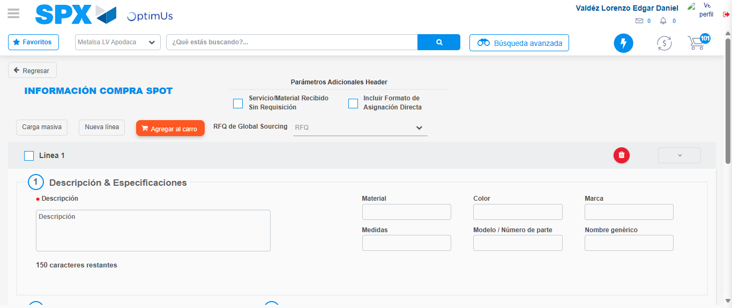Image file-name: QC_Testing-tc002_SPX_Dev5_Crear_Requisicion_Spot_Con_FAD_Tipo_Cobro_CC-1781656198757

Step 3 - Add FAD to Requisition: FAD Successfully Added
Image file-name: QC_Testing-tc002_SPX_Dev5_Crear_Requisicion_Spot_Con_FAD_Tipo_Cobro_CC-1781656198982

Image file-name: QC_Testing-tc002_SPX_Dev5_Crear_Requisicion_Spot_Con_FAD_Tipo_Cobro_CC-1781656199186

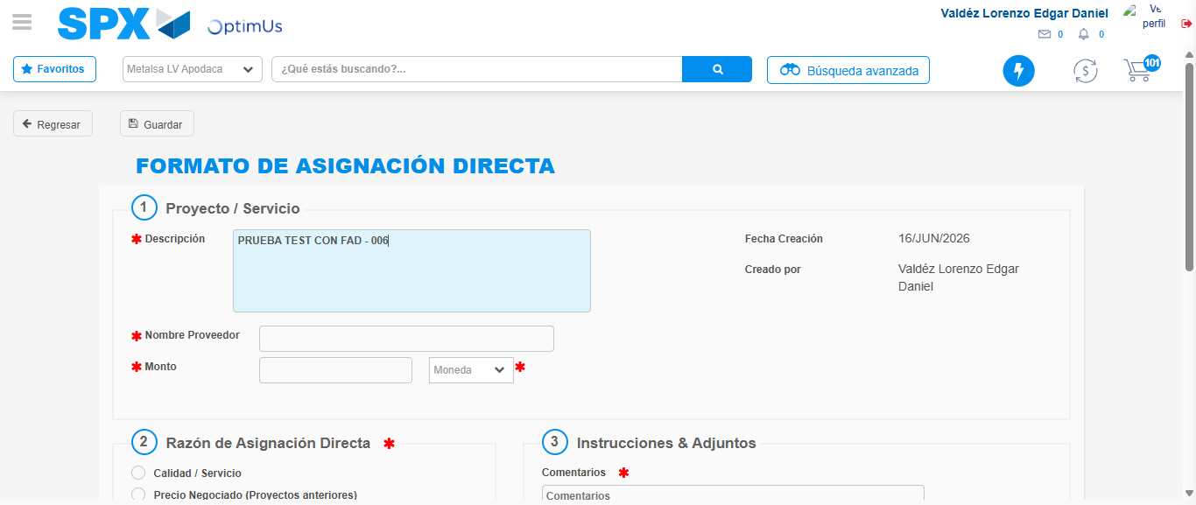Image file-name: QC_Testing-tc002_SPX_Dev5_Crear_Requisicion_Spot_Con_FAD_Tipo_Cobro_CC-1781656201885

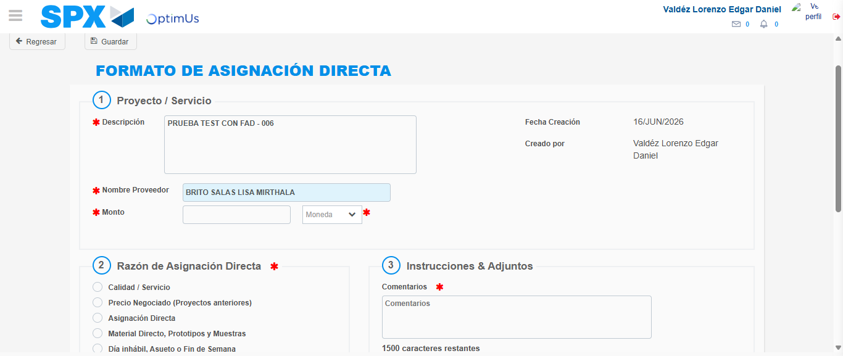Image file-name: QC_Testing-tc002_SPX_Dev5_Crear_Requisicion_Spot_Con_FAD_Tipo_Cobro_CC-1781656207178

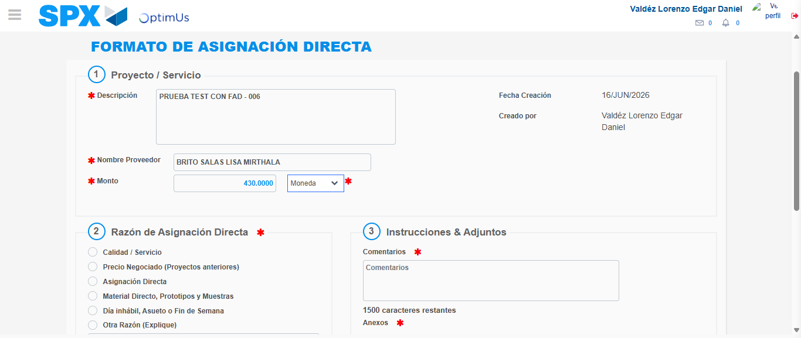Image file-name: QC_Testing-tc002_SPX_Dev5_Crear_Requisicion_Spot_Con_FAD_Tipo_Cobro_CC-1781656207590

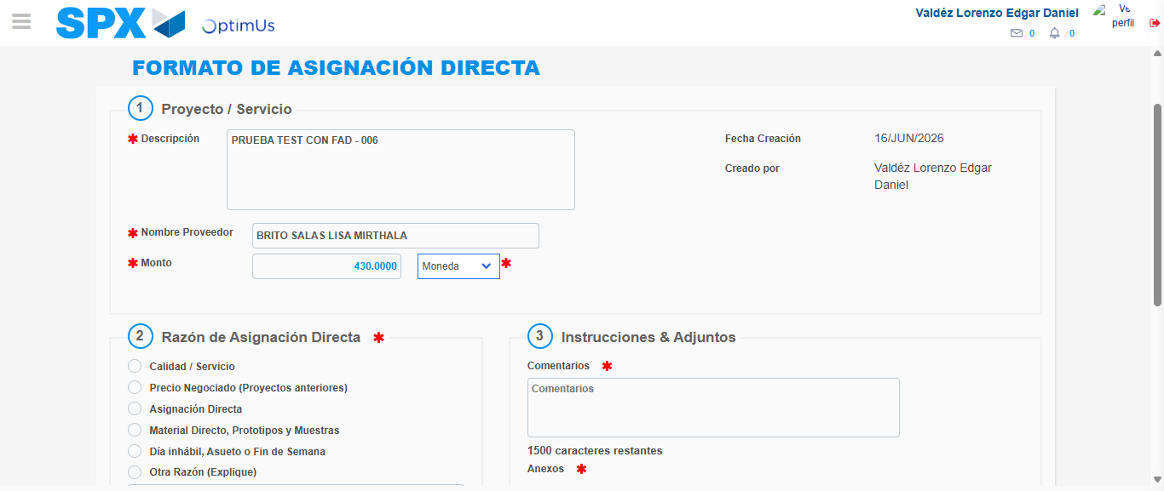Image file-name: QC_Testing-tc002_SPX_Dev5_Crear_Requisicion_Spot_Con_FAD_Tipo_Cobro_CC-1781656207789

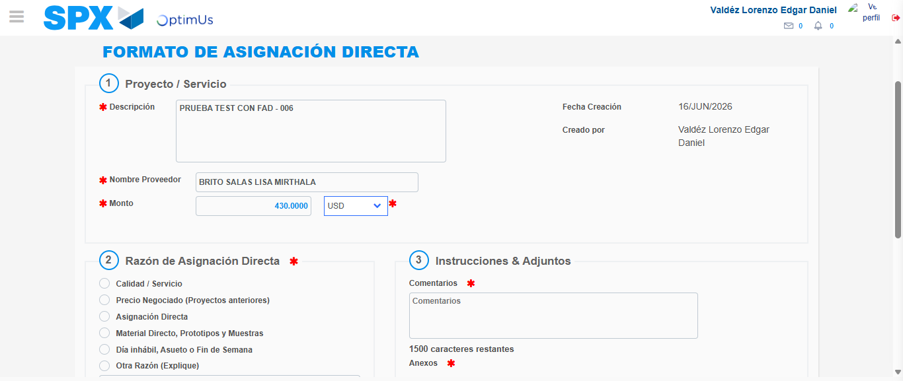Image file-name: QC_Testing-tc002_SPX_Dev5_Crear_Requisicion_Spot_Con_FAD_Tipo_Cobro_CC-1781656208162

Image file-name: QC_Testing-tc002_SPX_Dev5_Crear_Requisicion_Spot_Con_FAD_Tipo_Cobro_CC-1781656208355

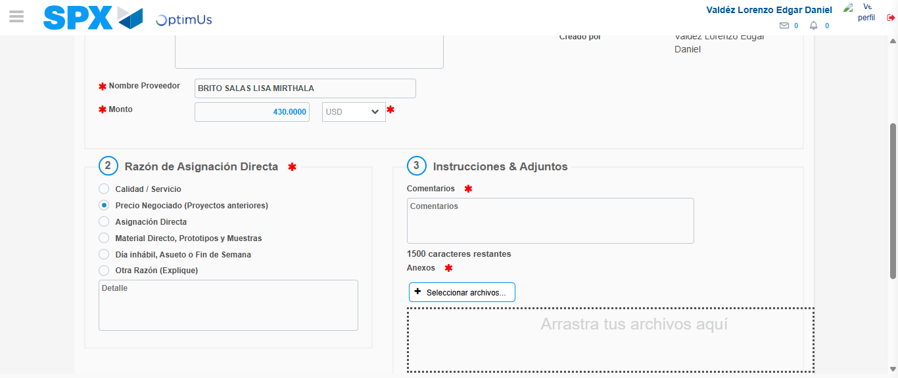Image file-name: QC_Testing-tc002_SPX_Dev5_Crear_Requisicion_Spot_Con_FAD_Tipo_Cobro_CC-1781656209227

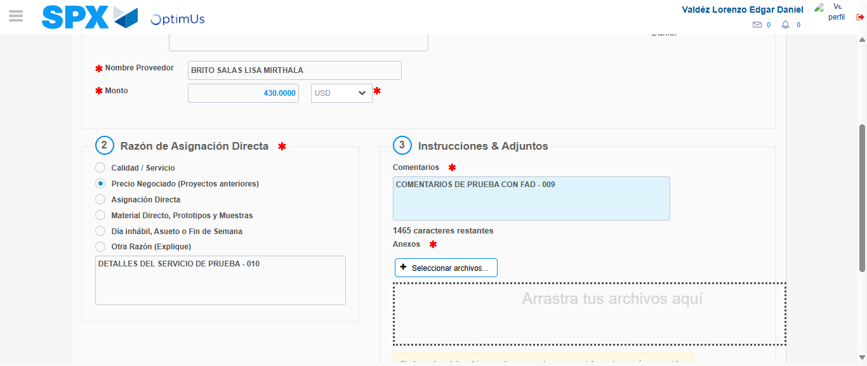Image file-name: QC_Testing-tc002_SPX_Dev5_Crear_Requisicion_Spot_Con_FAD_Tipo_Cobro_CC-1781656220159

Image file-name: QC_Testing-tc002_SPX_Dev5_Crear_Requisicion_Spot_Con_FAD_Tipo_Cobro_CC-1781656220919

Step 4 - Data Capture Spot Buy Requisition: Data captured correctly
Image file-name: QC_Testing-tc002_SPX_Dev5_Crear_Requisicion_Spot_Con_FAD_Tipo_Cobro_CC-1781656198982

Image file-name: QC_Testing-tc002_SPX_Dev5_Crear_Requisicion_Spot_Con_FAD_Tipo_Cobro_CC-1781656199186

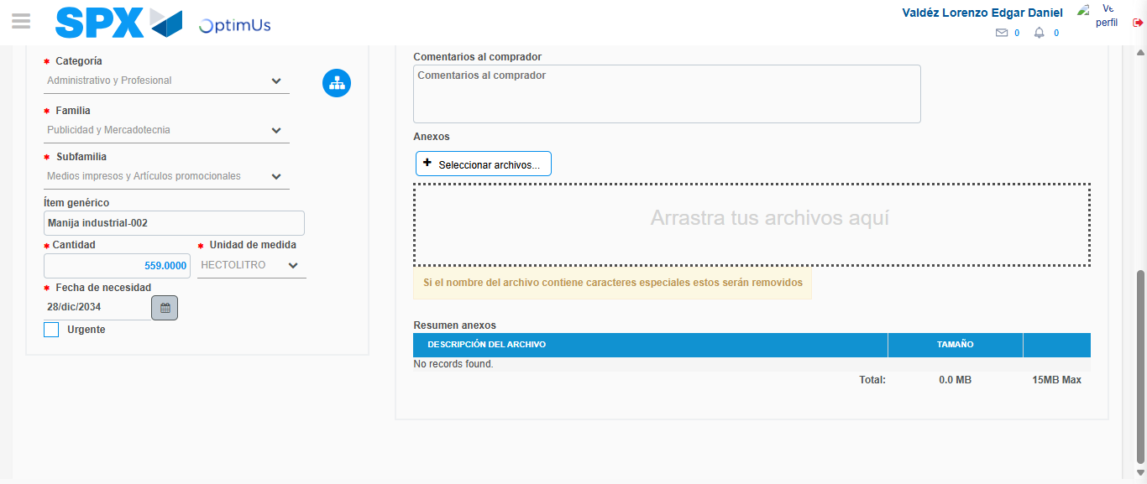Image file-name: QC_Testing-tc002_SPX_Dev5_Crear_Requisicion_Spot_Con_FAD_Tipo_Cobro_CC-1781656232941

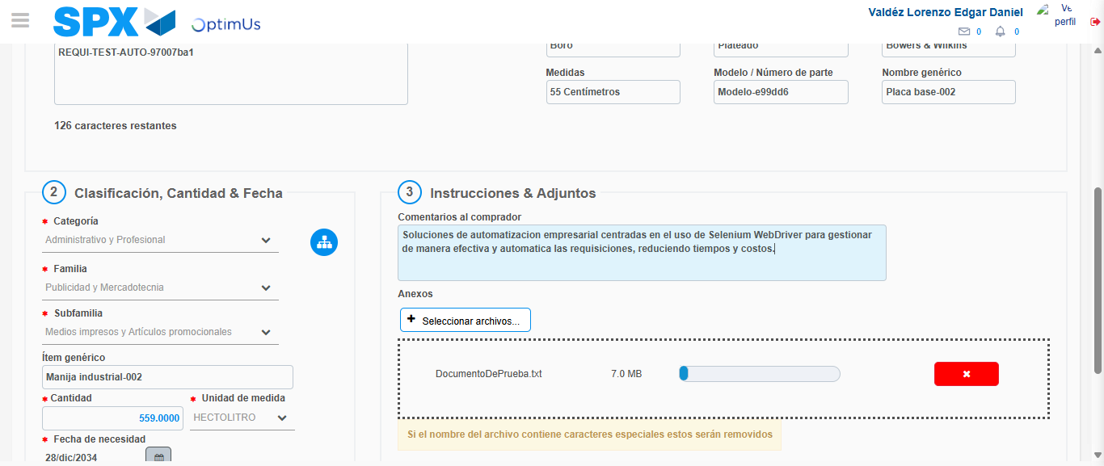Image file-name: QC_Testing-tc002_SPX_Dev5_Crear_Requisicion_Spot_Con_FAD_Tipo_Cobro_CC-1781656233696

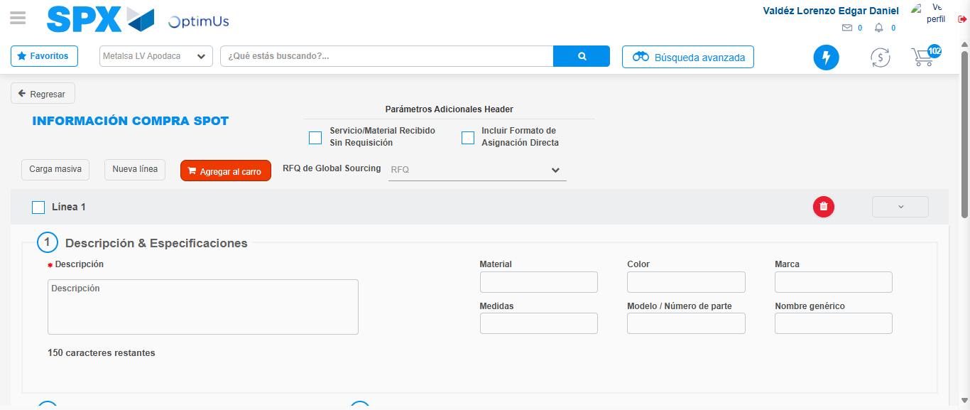Image file-name: QC_Testing-tc002_SPX_Dev5_Crear_Requisicion_Spot_Con_FAD_Tipo_Cobro_CC-1781656239209

Step 5 - Select to Requisition: Requisition Correctly selected
Image file-name: QC_Testing-tc002_SPX_Dev5_Crear_Requisicion_Spot_Con_FAD_Tipo_Cobro_CC-1781656239394

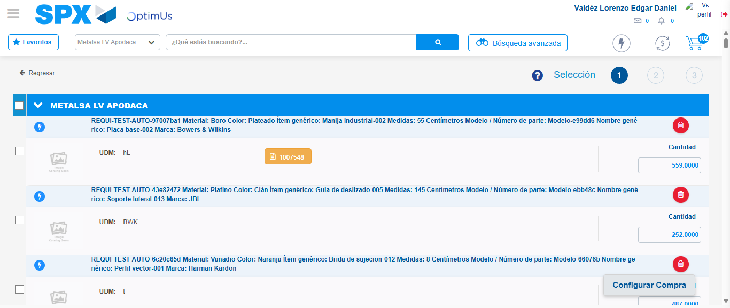Image file-name: QC_Testing-tc002_SPX_Dev5_Crear_Requisicion_Spot_Con_FAD_Tipo_Cobro_CC-1781656259320

Image file-name: QC_Testing-tc002_SPX_Dev5_Crear_Requisicion_Spot_Con_FAD_Tipo_Cobro_CC-1781656259537

Image file-name: QC_Testing-tc002_SPX_Dev5_Crear_Requisicion_Spot_Con_FAD_Tipo_Cobro_CC-1781656259739

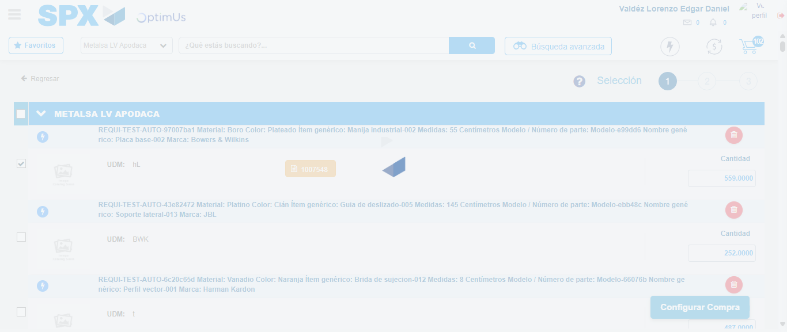Image file-name: QC_Testing-tc002_SPX_Dev5_Crear_Requisicion_Spot_Con_FAD_Tipo_Cobro_CC-1781656260622

Step 6 - Select Type Account For Requisition: Type Account Correctly selected
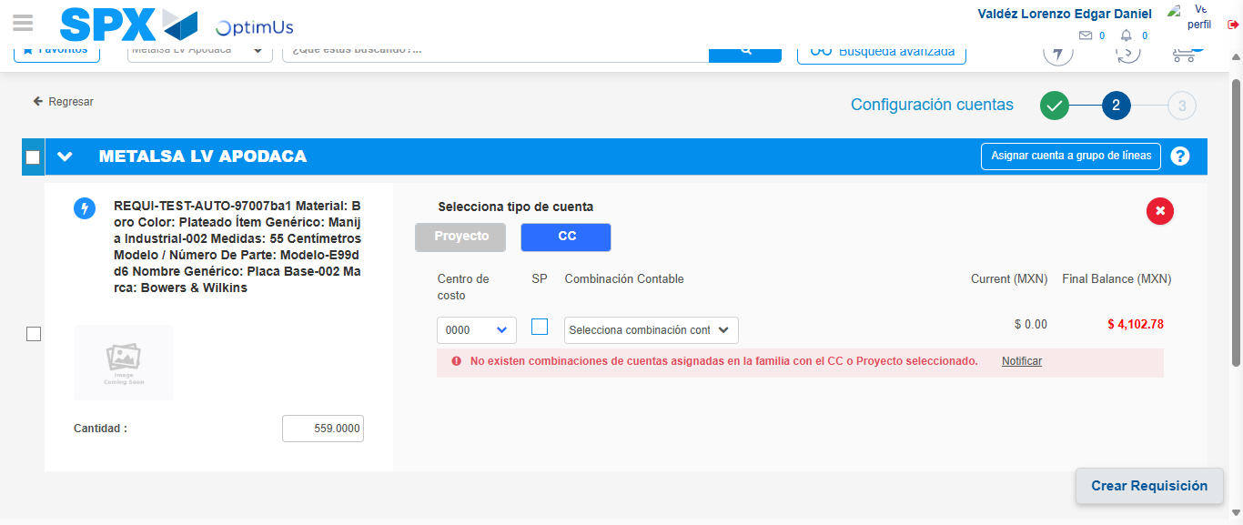Image file-name: QC_Testing-tc002_SPX_Dev5_Crear_Requisicion_Spot_Con_FAD_Tipo_Cobro_CC-1781656289206

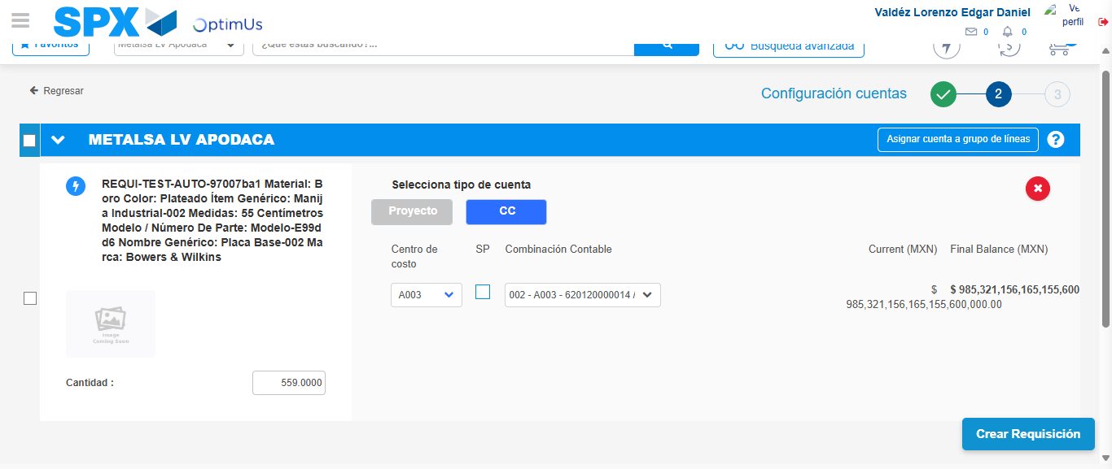Image file-name: QC_Testing-tc002_SPX_Dev5_Crear_Requisicion_Spot_Con_FAD_Tipo_Cobro_CC-1781656299830

Image file-name: QC_Testing-tc002_SPX_Dev5_Crear_Requisicion_Spot_Con_FAD_Tipo_Cobro_CC-1781656300008

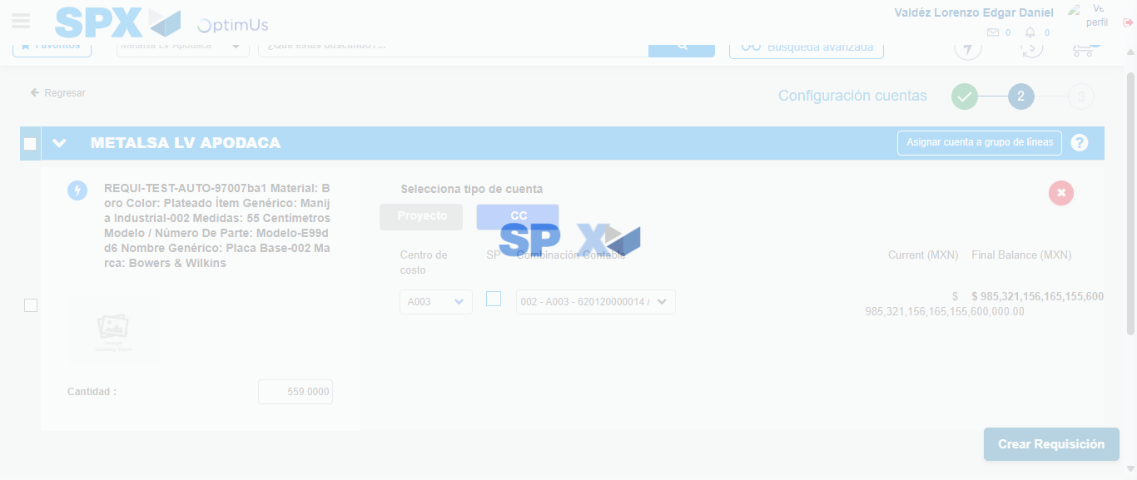Image file-name: QC_Testing-tc002_SPX_Dev5_Crear_Requisicion_Spot_Con_FAD_Tipo_Cobro_CC-1781656300362

Step 7 - Accept to Requisition: Requisition Accepted
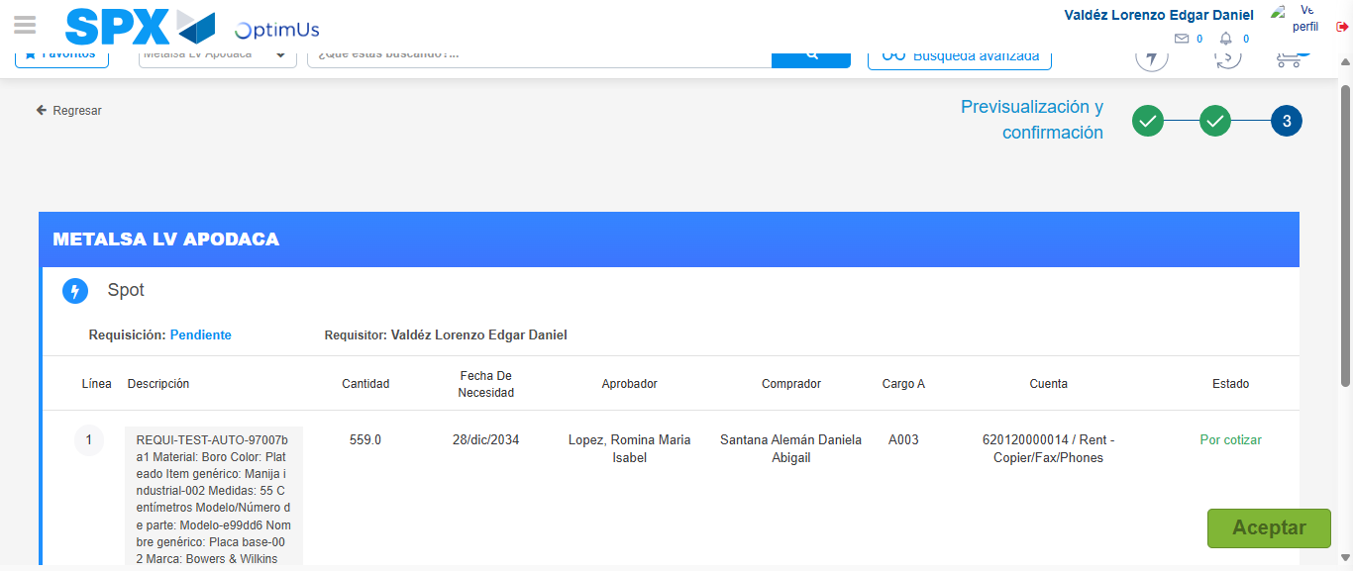Image file-name: QC_Testing-tc002_SPX_Dev5_Crear_Requisicion_Spot_Con_FAD_Tipo_Cobro_CC-1781656301692

Image file-name: QC_Testing-tc002_SPX_Dev5_Crear_Requisicion_Spot_Con_FAD_Tipo_Cobro_CC-1781656301893

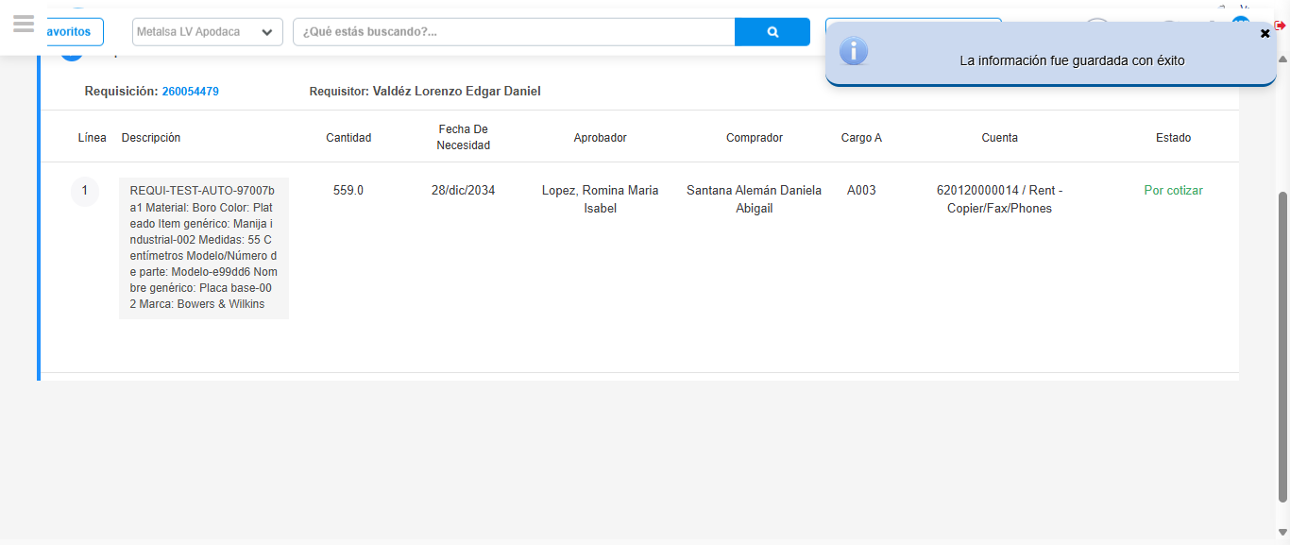Image file-name: QC_Testing-tc002_SPX_Dev5_Crear_Requisicion_Spot_Con_FAD_Tipo_Cobro_CC-1781656306432

Step 8 - Return to Main Page SPX : Return to Main Page SPX
Image file-name: QC_Testing-tc002_SPX_Dev5_Crear_Requisicion_Spot_Con_FAD_Tipo_Cobro_CC-1781656149370

Image file-name: QC_Testing-tc002_SPX_Dev5_Crear_Requisicion_Spot_Con_FAD_Tipo_Cobro_CC-1781656152000

Image file-name: QC_Testing-tc002_SPX_Dev5_Crear_Requisicion_Spot_Con_FAD_Tipo_Cobro_CC-1781656198757

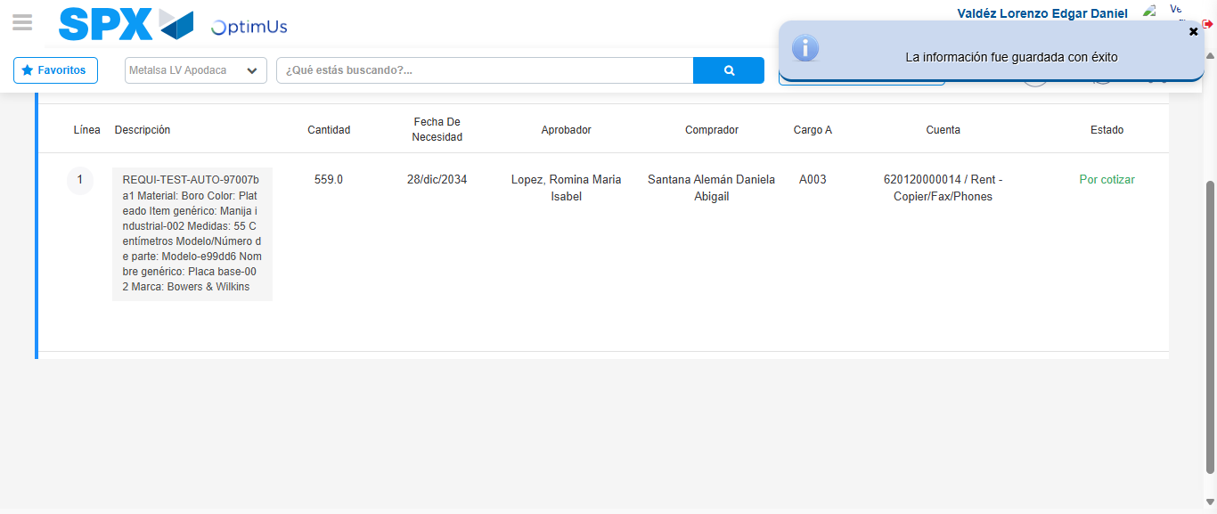Image file-name: QC_Testing-tc002_SPX_Dev5_Crear_Requisicion_Spot_Con_FAD_Tipo_Cobro_CC-1781656308655

Image file-name: QC_Testing-tc002_SPX_Dev5_Crear_Requisicion_Spot_Con_FAD_Tipo_Cobro_CC-1781656308827

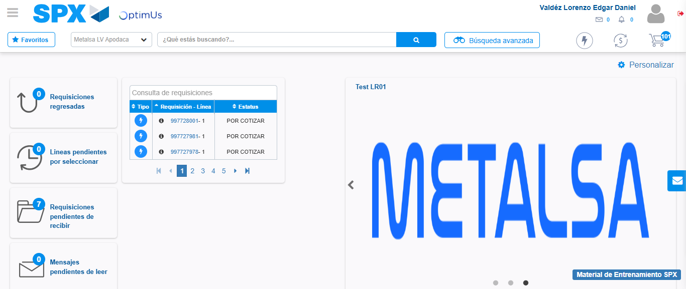Image file-name: QC_Testing-tc002_SPX_Dev5_Crear_Requisicion_Spot_Con_FAD_Tipo_Cobro_CC-1781656329869

Step 9 - Log Out : Log Out SPX
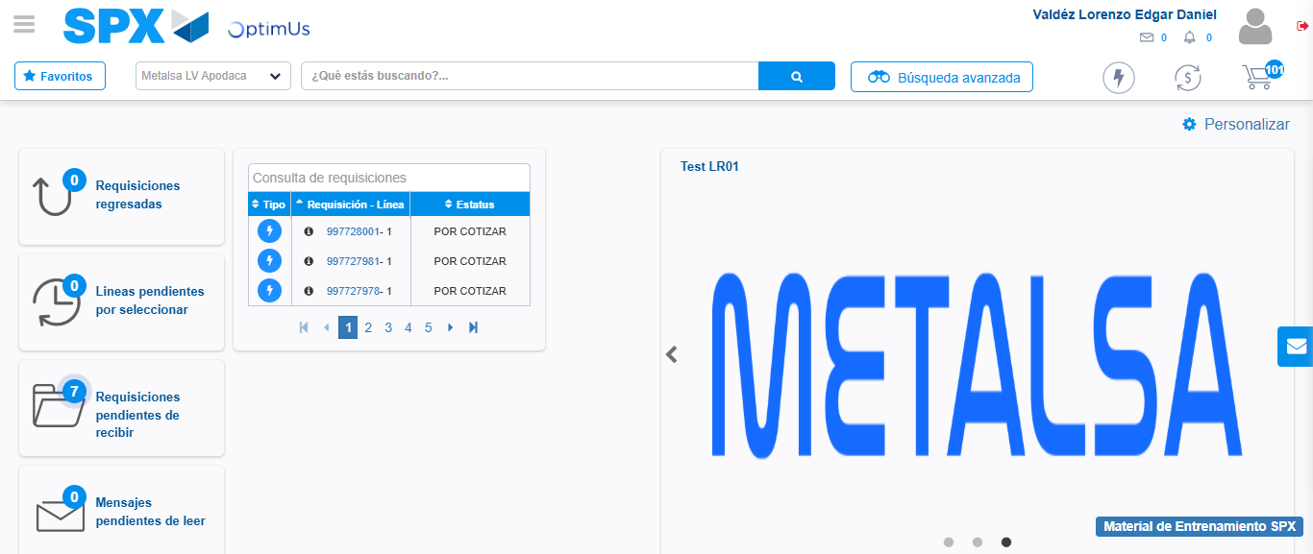Image file-name: QC_Testing-tc002_SPX_Dev5_Crear_Requisicion_Spot_Con_FAD_Tipo_Cobro_CC-1781656330119

